Filler Panel Request Form

Date: |  | Job name:
Ship to: |  | City, State:
Attn:
Address: |  | Ordered by:
City/St/Zip: |  | Phone:
Phone: |  | email:
email: |  | DSL/Case ID#:
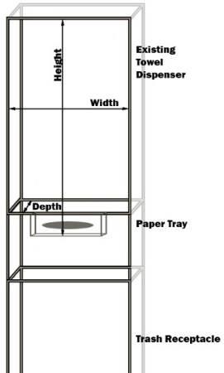
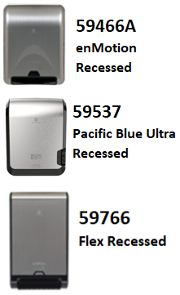
MEASURE
 | Total Quantity of enMotion® or Pacific Blue Ultra® Recessed panels needed.
 | Total Quantity of enMotion® FLEX panels needed.
How to measure for a filler panel:
View enMotion Recessed measuring instructions at: http://youtu.be/PsnyXddyUEw
Flex Recessed measuring/install: https://www.youtube.com/watch?v=ui0BF58uFTI
WIDTH: |  | Outside | Outside edge to Outside edge (closest 1/8”)
WIDTH: |  | Inside | Cavity Inside left to Inside right (closest 1/8”)
HEIGHT: |  | Outside | Outside edge to bottom of paper tray
HEIGHT: |  | Inside | Cavity Inside to bottom of paper tray
DEPTH:

ORDER
Quantity | Panel Requested | Width | Height Range | Panel Style
 | ER or PBUR: 57445: OM-22 | 17 3/8” | 16” to 22” | Outside Mount (preferred)
 | ER or PBUR: 57443: IN-22 | 15 1/8” to 15 ¼” | 20” to 22” | Inside Mount
 | ER or PBUR 57442: IN-20 | 15 1/8” to 15 ¼” | 18” to 20” | Inside Mount
 | FLEX: 57745: OM-24.5 | 17 3/8” | 18” to 24 1/2” | Outside Mount (preferred)
 | FLEX: 57743: IN-24.5 | 15 1/8” to 15 ¼” | 20” to 24 1/2” | Inside Mount
Common Custom Panels
 | ER or PBUR: OM-Contour | 17 5/8” | 16” to 22” | Outside Mount
 | ER or PBUR: Medcab-14.5 x 28.5 | 12” to 14 1/2” | 16” to 27 1/2” | Medcab
 | FLEX: OM-Contour | 17 5/8” | 20” to 2” | Outside Mount
 | FLEX: Medcab-14.5 x 28.5 | 12” to 14 1/2” | 20” to 27 1/2” | Medcab
Custom Panel Measurements – for best results, include picture of existing receptacle. Contact GPMS with questions.
Quantity | Width: Inside - Outside | Height | Depth | Panel Type – OM, IN or MEDCAB
 | -
 | -

- Forward order form along with enMotion Sublease/End User Lease to:
installs@gapacms.com or fax to 877-329-4767 – for best results, forward a digital picture of the existing receptacle.
- Custom filler panels ship within 5-7 business days of receipt of order/lease.
- Video of Inner Mount filler panel installation: https://www.youtube.com/watch?v=G0Y9mAqsJjU
- Video of Outer Mount filler panel installation: https://youtu.be/nTnhl-FAqVs
- Contact the GPMS Installation Team at 877-377-2737 with any questions. Thank you.

